## Front End Engineering-II

Project Report

Semester-IV (Batch-2022)

Product – Based Website

Creative Agency

**Supervised By: Submitted By:**

Raveesh Samkaria Swastik Verma

2210990882

G-13

**Department of Computer Science and Engineering**

## Chitkara University Institute of Engineering & Technology,

## Chitkara University, Punjab

**ABSTRACT**

The HTML document represents a website template for a creative agency. It includes multiple sections and elements designed to showcase the agency's services, creativity, and contact information.

1. **Header Section:**
   * Contains metadata like charset and viewport.
   * Includes a title and links to external CSS stylesheet and logo image file.
2. **Navigation Bar:**
   * Features a logo and navigation links for various pages including Contact Us, Pages, Services, Blog, About Us, and Home.
3. **Main Content Sections:**
   * **Section 1:**
     + Introduces the agency as a creative entity.
     + Includes a brief description, a call-to-action button, and an image.
   * **Section 2:**
     + Presents more detailed information about the agency's services.
     + Includes a title, description, and another call-to-action button.
   * **Section 3:**
     + Highlights what makes the agency awesome through images and accompanying text.
   * **Section 4:**
     + Showcases testimonials or additional information with images and text.
   * **Section 5:**
     + Features an image of an iPad with a heading.
   * **Section 6:**
     + Displays information about the agency's creativity and services.
   * **Section 7:**
     + Presents a series of images with accompanying text.
   * **Section 8:**
     + Provides contact information and a form for visitors to reach out.
   * **Section 9:**
     + Displays copyright information and credits.
4. **Footer Section:**
   * Contains a copyright notice and a mention of the website designer.

**1. Introduction**

The provided HTML code offers a structured foundation for a website tailored to represent a creative agency or design studio. With its meticulously crafted sections and engaging visual elements, this template aims to captivate visitors and showcase the agency's unique blend of creativity, professionalism, and expertise. From the sleek navigation bar to the compelling call-to-action buttons and visually appealing imagery, every aspect of the design serves to communicate the agency's brand identity and value proposition. Through this template, the agency endeavors to establish a strong online presence and attract potential clients seeking innovative design solutions.

**1.1 Background:**

The HTML code represents the foundation of a website designed for a vibrant and innovative creative agency. The agency, likely aiming to establish a strong online presence, utilizes this template to showcase its unique approach, services, and portfolio to potential clients and visitors.

**Key Elements:**

1. **Branding and Identity:**
   * The inclusion of a logo in the navigation bar emphasizes the agency's branding and creates a visual identity for the website.
2. **Navigation and Accessibility:**
   * The navigation bar provides easy access to different sections of the website, ensuring smooth navigation for users to explore various pages and services.
3. **Engagement and Call-to-Action:**
   * Sections with bold headings and compelling descriptions aim to engage visitors and encourage them to explore further or take action, such as clicking on buttons to learn more or contact the agency.
4. **Visual Appeal and Creativity:**
   * The use of images, both in the main content sections and testimonials, enhances the visual appeal of the website, reflecting the agency's creative prowess and portfolio.
5. **Client Interaction and Contact Information:**
   * The inclusion of a contact form and detailed contact information at the end of the page facilitates communication between the agency and potential clients, fostering a seamless interaction process.
6. **Responsive Design:**
   * The meta viewport tag and the use of CSS classes suggest that the website is designed to be responsive, ensuring optimal viewing experience across various devices and screen sizes.

**1.2 Objectives:**

The objective of the provided HTML code is to create a visually appealing and informative website template for a creative agency. The code aims to:

1. **Introduce the Agency:** Present the agency's brand and identity through a logo and navigation bar.
2. **Showcase Services:** Highlight the services offered by the agency through descriptive sections and images.
3. **Engage Visitors:** Encourage user interaction through call-to-action buttons and forms.
4. **Demonstrate Creativity:** Display the agency's creative prowess through visually appealing design elements, such as images and graphics.
5. **Provide Contact Information:** Enable visitors to easily get in touch with the agency by including contact details and a contact form.

**1.3 Significance:**

The significance of this HTML code lies in its role as a template for a website, specifically designed for a creative agency. Here are some key points regarding its significance:

1. **Professional Appearance**: The code creates a visually appealing and professional-looking website layout, which is crucial for establishing credibility and attracting potential clients or visitors.
2. **User Experience**: It emphasizes user experience through clear navigation, organized content sections, and visually appealing elements such as images and buttons. This enhances engagement and encourages visitors to explore the site further.
3. **Branding and Identity**: The inclusion of a logo, consistent color scheme, and typography helps to reinforce the agency's branding and identity, contributing to brand recognition and recall.
4. **Showcasing Services and Portfolio**: The code structure allows for effective presentation of the agency's services, portfolio, and achievements. This enables potential clients to understand the agency's capabilities and previous work, which can influence their decision to engage with the agency.
5. **Call-to-Action**: The strategically placed call-to-action buttons prompt visitors to take desired actions, such as contacting the agency or exploring specific services further. This helps in driving conversions and achieving business goals.
6. **Accessibility and Responsiveness**: The code includes meta tags for viewport settings, indicating responsiveness to different device sizes. This ensures that the website is accessible and functional across various devices, including desktops, tablets, and smartphones.
7. **Contact and Interaction**: The provision of contact information and a form encourages interaction with visitors, allowing them to reach out to the agency easily. This facilitates communication and potential collaboration opportunities.

**Problem Definition:**

The problem this code addresses is the creation of a website template for a creative agency. The goal is to design a visually appealing and informative online presence that effectively showcases the agency's services, creativity, and contact information to potential clients or visitors.

Key aspects of the problem include:

1. **Design and Layout:** The website must have an attractive design and layout that reflects the creative nature of the agency. This involves choosing appropriate fonts, colors, and imagery to create a visually appealing experience.
2. **Content Presentation:** The content needs to be organized and presented in a clear and engaging manner. This includes providing descriptions of the agency's services, showcasing past work or projects, and highlighting what makes the agency unique.
3. **Navigation:** The website must have intuitive navigation that allows visitors to easily find the information they are looking for. This involves designing a user-friendly navigation bar and ensuring that links are descriptive and lead to relevant pages.
4. **Contact Information:** It's essential to prominently display contact information so that potential clients can easily get in touch with the agency. This may include providing a contact form, email address, phone number, and physical address.
5. **Responsive Design:** The website should be responsive and accessible across different devices and screen sizes. This ensures a consistent user experience regardless of whether visitors are accessing the site on a desktop, tablet, or mobile device.
6. **Code Quality:** The HTML code should be well-structured, semantic, and adhere to best practices for web development. This includes using appropriate HTML tags, avoiding inline styling whenever possible, and ensuring accessibility for users with disabilities.

**Requirements:**

Addressing the identified problems necessitates a set of well-defined requirements that guide the development of the Product-Based website template. These requirements serve as a roadmap, outlining the key functionalities and characteristics that the solution must embody:

1. Responsive Design: The template must be responsive, dynamically adjusting its layout and content to provide an optimal viewing experience on devices of varying screen sizes.
2. Intuitive Navigation: User-friendly navigation is crucial. The template should incorporate an intuitive menu structure that allows users to seamlessly explore different sections of the website.
3. Consistent Aesthetics: A visually consistent design aesthetic is essential to ensure a cohesive brand identity. The template should maintain visual harmony across desktop and mobile platforms.
4. Dynamic Menu Interface: An interactive and dynamic menu interface is required to enhance user engagement, enabling swift and effortless navigation throughout the website.
5. Clear Call-to-Action: Strategic placement of clear call-to-action buttons is necessary to guide users through the desired actions, such as placing orders or exploring specific services.
6. Efficient Order Placement Process: Streamlining the order placement process is critical. The template must facilitate a straightforward journey from product selection to order completion.
7. Optimized Performance: Performance optimization is paramount. The template should prioritize fast loading times and efficient resource utilization to enhance the overall user experience.

By elucidating the problems faced by agencies in the digital realm and establishing clear requirements, this section sets the stage for the subsequent design and development phases. The envisioned Agency-Based website template aims not only to address these challenges but also to surpass expectations, providing a comprehensive solution that aligns with the evolving needs of the online landscape.

**Proposed Design and Methodology:**

The proposed design and methodology for developing the website template for the creative agency involves a systematic approach to ensure an effective and visually appealing outcome. Here's a breakdown of the steps:

1. **Requirement Analysis:**
   * Conduct a thorough analysis of the agency's requirements, including their branding guidelines, target audience, and desired features for the website.
2. **Wireframing and Prototyping:**
   * Create wireframes and prototypes to visualize the layout and structure of the website. This helps in establishing the hierarchy of information and determining the placement of key elements such as navigation, content sections, and contact details.
3. **Design Conceptualization:**
   * Develop a design concept that aligns with the agency's brand identity and ethos. This involves selecting appropriate color palettes, typography, imagery, and graphic elements to create a cohesive visual identity.
4. **HTML Structure:**
   * Begin by setting up the HTML structure of the website, including the necessary tags and elements to define the layout and content sections. Ensure semantic markup and proper organization of content for accessibility and SEO optimization.
5. **Styling with CSS:**
   * Apply CSS styles to enhance the visual appearance of the website, including font styles, colors, spacing, and responsive design techniques. Utilize external CSS files to maintain consistency and modularity in styling.
6. **Content Integration:**
   * Integrate the agency's content, including descriptions of services, portfolio items, team profiles, and contact information, into the HTML structure. Ensure that content is presented in a visually appealing and easily digestible format.
7. **Navigation Implementation:**
   * Implement intuitive navigation features, such as a navigation bar with dropdown menus or a hamburger menu for mobile devices, to facilitate easy navigation between pages and sections of the website.
8. **Testing and Optimization:**
   * Conduct thorough testing of the website across different browsers, devices, and screen sizes to ensure compatibility and responsiveness. Identify and fix any usability issues, layout inconsistencies, or performance bottlenecks.
9. **Documentation and Deployment:**
   * Document the design and development process, including any custom functionalities or third-party integrations. Prepare the website for deployment on a hosting server, ensuring proper configuration and optimization for speed

**Result: **

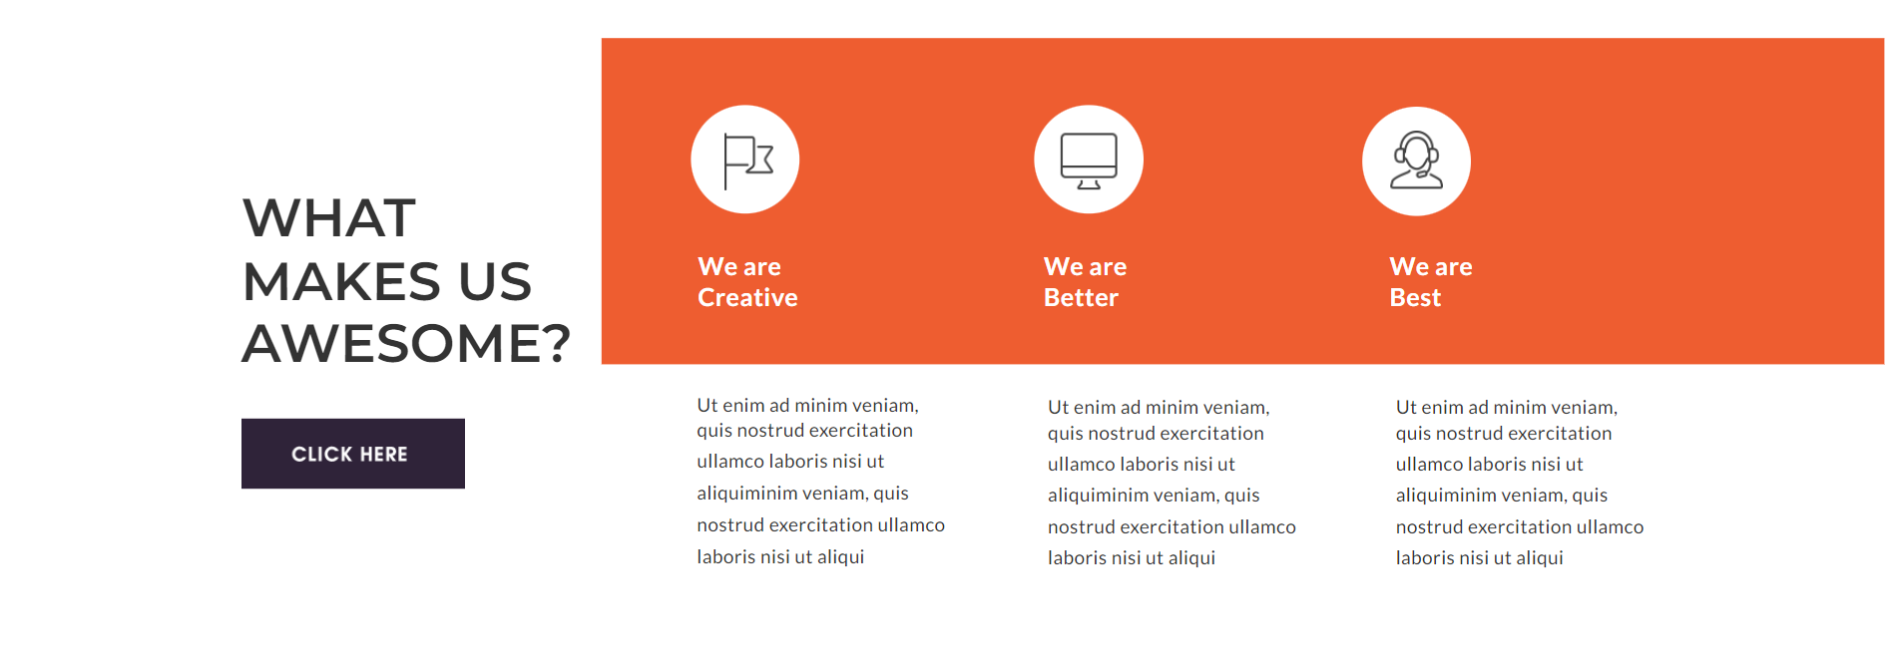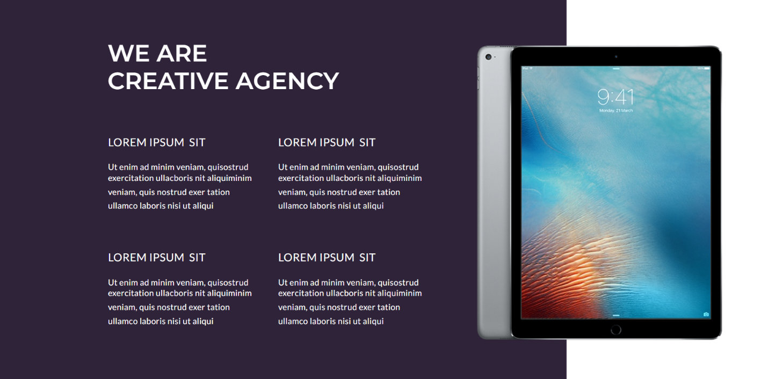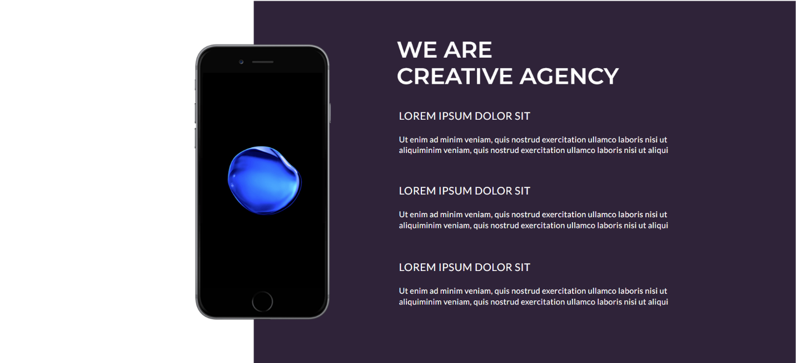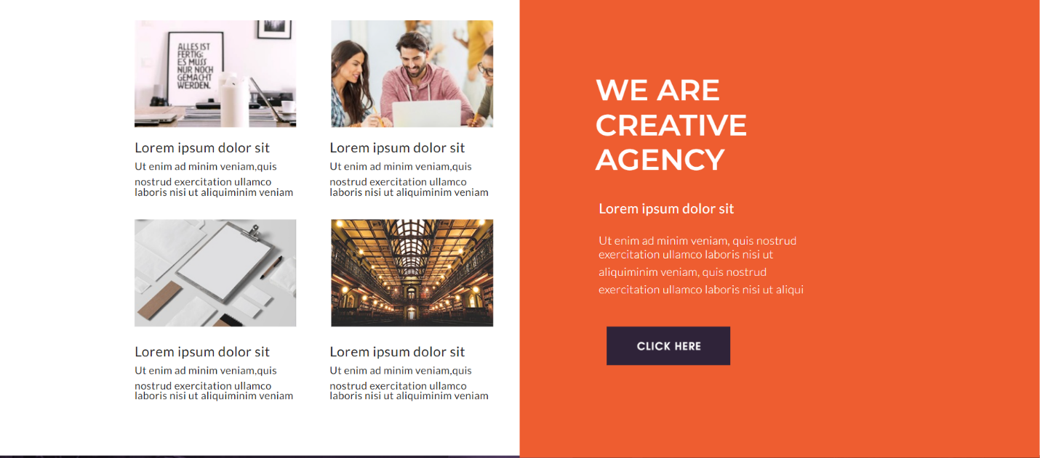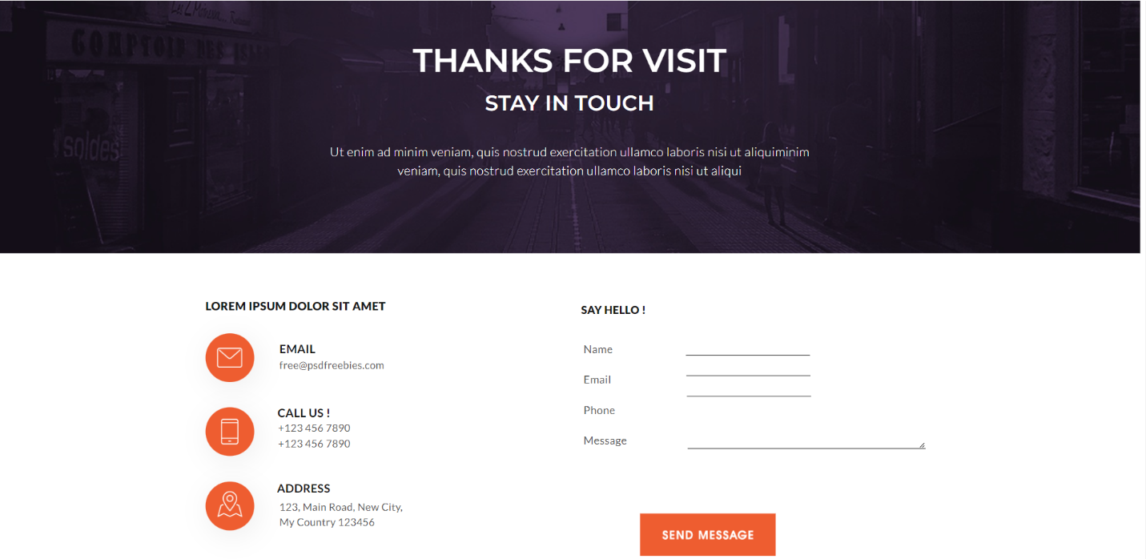



**CODE:-**

*HTML*

<!doctype html>

<html>

  <head>

    <title>Apple.Rimt</title>

    <meta charset="UTF-8">

    <meta name="viewport" content="width=device-width,initial-scale=1">

    <meta http-equiv="X-UA-Compatible" content="IE=Edge">

    <link rel="stylesheet" href="style.css">

    <link rel="stylesheet" href="https://fonts.googleapis.com/css?family=Montserrat:100,100italic,200,200italic,300,300italic,regular,italic,500,500italic,600,600italic,700,700italic,800,800italic,900,900italic&amp;subset=cyrillic,cyrillic-ext,latin,latin-ext,vietnamese">

    <link rel="stylesheet" href="https://fonts.googleapis.com/css?family=Lato:100,100italic,300,300italic,regular,italic,700,700italic,900,900italic&amp;subset=latin,latin-ext">

  </head>

  <body>

    <div class="background">

      <div class="bg">

        <div class="l-constrained-4 group">

          <div class="logo group">

            <img class="shape-1" src="images/shape_1.png" alt="" width="53" height="52">

            <div class="col-6">

              <img class="webpro" src="images/webpro.png" alt="WebPro" width="144" height="26" title="WebPro">

              <p class="text">Tagline here</p>

            </div>

          </div>

          <img class="text-2" src="images/image.png" alt=" " width="145" height="19" title=" ">

          <nav class="nav">

            <ul class="nav-list group">

              <li><p class="nav-item-1"><a href="#">Home</a></p></li>

              <li><p class="nav-item-1-2"><a href="#">About us</a></p></li>

              <li><p class="nav-item-1-3"><a href="#">blog</a></p></li>

              <li><p class="nav-item-1-4"><a href="#">services</a></p></li>

              <li><p class="nav-item-1-5"><a href="#">pages</a></p></li>

              <li><p class="nav-item-1-6"><a href="#">Contact us</a></p></li>

            </ul>

          </nav>

          <button class="menu-btn" onclick="toggleMenu()"><svg xmlns="http://www.w3.org/2000/svg" viewBox="0 0 448 512"><!--!Font Awesome Free 6.5.1 by @fontawesome - https://fontawesome.com License - https://fontawesome.com/license/free Copyright 2024 Fonticons, Inc.--><path d="M0 96C0 78.3 14.3 64 32 64H416c17.7 0 32 14.3 32 32s-14.3 32-32 32H32C14.3 128 0 113.7 0 96zM0 256c0-17.7 14.3-32 32-32H416c17.7 0 32 14.3 32 32s-14.3 32-32 32H32c-17.7 0-32-14.3-32-32zM448 416c0 17.7-14.3 32-32 32H32c-17.7 0-32-14.3-32-32s14.3-32 32-32H416c17.7 0 32 14.3 32 32z"/></svg></button>

        </div>

      </div>

      <div class="background-image">

        <div class="copy">

          <p class="text-3">We Are<br>Creative<br>Agency</p>

          <p class="text-4">Lorem ipsum dolor sit amet, consectetur adipiscing elit, sed do eiusmod tempor incididunt ut labore et Lorem ipsum dolor sit amet, consectetur adipiscing elit, sed do eiusmod tempor incididunt ut labore et</p>

          <div class="rectangle-6-copy-7-holder">

            <img class="text-5" src="images/click_here.png" alt="Click here" width="110" height="15" title="Click here">

          </div>

        </div>

      </div>

      <div class="l-constrained">

        <div class="group-2">

          <div class="rectangle-1-holder">

            <div class="copy-2">

              <p class="text-6">We Are<br>Creative Agency</p>

              <p class="text-7"><span class="colorffffff">Lorem ipsum dolor sit amet, consectetur adipiscing elit, sed do eiusmod tempor incididunt ut labore et </span><br><span class="text-style">&nbsp;</span><br>Ut enim ad minim veniam, quis nostrud exercitation ullamco laboris nisi ut aliquip ex ea commodo consequat. Duis aute irure dolor in reprehenderit in voluptate velit esse cillum dolore eu fugiat nulla pariatur.Lorem ipsum dolor sit amet, consectetur adipiscing elit, sed do eiusmod tempor incididunt ut labore et dolore magna aliqua.</p>

              <div class="rectangle-6-copy-4-holder">

                <img class="text-8" src="images/click_here.png" alt="Click here" width="110" height="15" title="Click here">

              </div>

            </div>

          </div>

          <img class="rectangle-3" src="images/rectangle_3_2.jpg" alt="">

        </div>

        <div class="group-3 group">

          <div class="col-2">

            <p class="text-9">What<br>Makes us<br>Awesome?</p>

            <div class="button">

              <img class="text-10" src="images/click_here.png" alt="Click here" width="110" height="15" title="Click here">

            </div>

          </div>

          <div class="wrapper-3">

            <div class="rectangle-1-copy-4"></div>

            <div class="group-4">

              <div class="ellipse-1-copy-2-holder">

                <img class="icon" src="images/icon_4.png" alt="" width="50" height="55">

              </div>

              <p class="text-11">We are<br>Best</p>

              <p class="text-12">Ut enim ad minim veniam, quis <span class="text-style">nostrud exercitation ullamco laboris nisi ut aliquiminim veniam, quis nostrud exercitation ullamco laboris nisi ut aliqui</span></p>

            </div>

            <div class="group-5">

              <div class="ellipse-1-copy-holder">

                <img class="icon-2" src="images/icon_5.png" alt="" width="54" height="54">

              </div>

              <p class="text-13">We are<br>Better</p>

              <p class="text-14">Ut enim ad minim veniam, quis <span class="text-style">nostrud exercitation ullamco laboris nisi ut aliquiminim veniam, quis nostrud exercitation ullamco laboris nisi ut aliqui</span></p>

            </div>

            <div class="group-6">

              <div class="ellipse-1-holder">

                <img class="icon-3" src="images/icon_6.png" alt="" width="47" height="55">

              </div>

              <p class="text-15">We are<br>Creative</p>

              <p class="text-16">Ut enim ad minim veniam, quis <span class="text-style">nostrud exercitation ullamco laboris nisi ut aliquiminim veniam, quis nostrud exercitation ullamco laboris nisi ut aliqui</span></p>

            </div>

          </div>

        </div>

        <div class="group-7">

          <div class="rectangle-1-copy-holder">

            <div class="copy-3">

              <p class="text-17">We Are<br>Creative Agency</p>

              <div class="row-2 match-height group">

                <div class="col-13">

                  <p><span class="text-style-2">Lorem ipsum &nbsp;sit</span><br><span class="text-style">&nbsp;</span><br><span class="text-style-3">Ut enim ad minim veniam, quisostrud exercitation ullacboris nit </span><span class="text-style">aliquiminim veniam, quis nostrud exer tation ullamco laboris nisi ut aliqui</span></p>

                  <p class="text-19"><span class="text-style-2">Lorem ipsum &nbsp;sit</span><br><span class="text-style">&nbsp;</span><br><span class="text-style-3">Ut enim ad minim veniam, quisostrud exercitation ullacboris nit </span><span class="text-style">aliquiminim veniam, quis nostrud exer tation ullamco laboris nisi ut aliqui</span></p>

                </div>

                <div class="col-14">

                  <p><span class="text-style-2">Lorem ipsum &nbsp;sit</span><br><span class="text-style">&nbsp;</span><br><span class="text-style-3">Ut enim ad minim veniam, quisostrud exercitation ullacboris nit </span><span class="text-style">aliquiminim veniam, quis nostrud exer tation ullamco laboris nisi ut aliqui</span></p>

                  <p class="text-21"><span class="text-style-2">Lorem ipsum &nbsp;sit</span><br><span class="text-style">&nbsp;</span><br><span class="text-style-3">Ut enim ad minim veniam, quisostrud exercitation ullacboris nit </span><span class="text-style">aliquiminim veniam, quis nostrud exer tation ullamco laboris nisi ut aliqui</span></p>

                </div>

              </div>

            </div>

          </div>

          <div class="ipad-image">

            <img class="place-your-screen" src="images/place_your_screen_2.jpg" alt="" width="410" height="548">

          </div>

        </div>

      </div>

      <div class="group-8">

        <div class="background-2"></div>

        <div class="apple-watch">

          <img class="place-your-screen1" src="images/place_your_screen1.jpg" alt="" width="210" height="263">

        </div>

        <div class="text-22">

          <p class="text-23"><span class="text-style-2">Lorem ipsum &nbsp;sit</span><br><span class="text-style">&nbsp;</span><br><span class="text-style-3">Ut enim ad minim veniam, quisostrud exercitation ullacboris nit </span><span class="text-style">aliquiminim veniam, quis nostrud exer tation ullamco laboris nisi ut aliqui</span></p>

          <p class="text-24">We Are<br>Creative</p>

        </div>

      </div>

      <div class="l-constrained-2">

        <div class="group-9">

          <div class="rectangle-1-copy-2-holder">

            <div class="text-25">

              <p class="text-26">We Are<br>Creative Agency</p>

              <p class="text-27"><span class="text-style-2">Lorem ipsum dolor sit</span><br><span class="text-style">&nbsp;</span><br><span class="text-style-3">Ut enim ad minim veniam, quis nostrud exercitation ullamco laboris nisi ut </span><span class="text-style">aliquiminim veniam, quis nostrud exercitation ullamco laboris nisi ut aliqui</span></p>

              <p class="text-28"><span class="text-style-2">Lorem ipsum dolor sit</span><br><span class="text-style">&nbsp;</span><br><span class="text-style-3">Ut enim ad minim veniam, quis nostrud exercitation ullamco laboris nisi ut </span><span class="text-style">aliquiminim veniam, quis nostrud exercitation ullamco laboris nisi ut aliqui</span></p>

              <p class="text-29"><span class="text-style-2">Lorem ipsum dolor sit</span><br><span class="text-style">&nbsp;</span><br><span class="text-style-3">Ut enim ad minim veniam, quis nostrud exercitation ullamco laboris nisi ut </span><span class="text-style">aliquiminim veniam, quis nostrud exercitation ullamco laboris nisi ut aliqui</span></p>

            </div>

          </div>

          <div class="iphone">

            <img class="place-your-screen-2" src="images/place_your_screen.png" alt="" width="270" height="488">

          </div>

        </div>

        <div class="group-10 group">

          <div class="articles match-height group">

            <div class="col-3">

              <div class="group-11">

                <img class="rectangle-2" src="images/rectangle_2.jpg" alt="">

                <p class="text-30"><span class="text-style-4">Lorem ipsum dolor sit</span><br><span class="text-style-5">Ut enim ad minim veniam,quis </span>nostrud exercitation ullamco laboris nisi ut aliquiminim veniam</p>

              </div>

              <div class="group-12">

                <img class="rectangle-2-copy-2" src="images/rectangle_2_copy_2_2.jpg" alt="">

                <p class="text-31"><span class="text-style-4">Lorem ipsum dolor sit</span><br><span class="text-style-5">Ut enim ad minim veniam,quis </span>nostrud exercitation ullamco laboris nisi ut aliquiminim veniam</p>

              </div>

            </div>

            <div class="col-4">

              <div class="group-13">

                <img class="rectangle-2-copy" src="images/rectangle_2_copy.jpg" alt="">

                <p class="text-32"><span class="text-style-4">Lorem ipsum dolor sit</span><br><span class="text-style-5">Ut enim ad minim veniam,quis </span>nostrud exercitation ullamco laboris nisi ut aliquiminim veniam</p>

              </div>

              <div class="group-14">

                <img class="rectangle-2-copy-2-2" src="images/rectangle_2_copy_2.jpg" alt="">

                <p class="text-33"><span class="text-style-4">Lorem ipsum dolor sit</span><br><span class="text-style-5">Ut enim ad minim veniam,quis </span>nostrud exercitation ullamco laboris nisi ut aliquiminim veniam</p>

              </div>

            </div>

          </div>

          <div class="rectangle-1-copy-6-holder">

            <div class="side-text">

              <p class="text-34">We Are<br>Creative<br>Agency</p>

              <p class="text-35"><span class="text-style-6">Lorem ipsum dolor sit</span><br><span class="text-style">&nbsp;</span><br><span class="text-style-7">Ut enim ad minim veniam, quis nostrud exercitation ullamco laboris nisi </span><span class="text-style">ut aliquiminim veniam, quis nostrud exercitation ullamco laboris nisi ut aliqui</span></p>

              <div class="rectangle-6-copy-6-holder">

                <img class="text-36" src="images/click_here.png" alt="Click here" width="110" height="15" title="Click here">

              </div>

            </div>

          </div>

        </div>

      </div>

      <div class="group-15 group">

        <div class="background-3">

          <div class="heading-and-text">

            <p class="text-37">Thanks for Visit</p>

            <p class="text-38">Stay in touch</p>

            <p class="text-39"><span class="text-style-7">Ut enim ad minim veniam, quis nostrud exercitation ullamco laboris nisi </span><span class="text-style">ut aliquiminim veniam, quis nostrud exercitation ullamco laboris nisi ut aliqui</span></p>

          </div>

        </div>

        <div class="get-in-touch group">

          <div class="contac-info">

            <p class="text-40">Lorem ipsum dolor sit amet</p>

            <div class="email group">

              <div class="ellipse-1-copy-3-holder">

                <img class="icon-4" src="images/icon_2.png" alt="" width="40" height="31">

              </div>

              <div class="col-8">

                <p class="email-2">Email</p>

                <p class="text-41">free@psdfreebies.com</p>

              </div>

            </div>

            <div class="call group">

              <div class="ellipse-1-copy-4-holder">

                <img class="icon-5" src="images/icon_3.png" alt="" width="27" height="40">

              </div>

              <div class="col-9">

                <p class="text-42">Call Us !</p>

                <p class="text-43">+123 456 7890<br>+123 456 7890</p>

              </div>

            </div>

            <div class="address match-height group">

              <div class="ellipse-1-copy-5-holder">

                <img class="icon-6" src="images/icon.png" alt="" width="39" height="40">

              </div>

              <div class="col-7">

                <p class="address-2">Address</p>

                <p class="text-44">123, Main Road, New City, My Country 123456</p>

              </div>

            </div>

          </div>

          <div class="contact-form group">

            <p class="text-45">say hello !</p>

            <div class="row group">

              <p class="text-46">Name<br><span class="text-style-8">&nbsp;</span><br>Email<br><span class="text-style-8">&nbsp;</span><br>Phone<br><span class="text-style-8">&nbsp;</span><br>Message</p>

              <form action="/submit-form" method="post" class="">

                <div class="form-group">

                <label for="name" class="form-label">Name:</label><br>

                <input type="text" id="name" name="name" class="form-input" style="margin-left: 21px; border: none; border-bottom: 1px solid black;"><br>

                    </div>

                <div class="form-group">

                <label for="email" class="form-label">Email:  </label><br>

                <input type="email" id="email" name="email" class="form-input" style="margin-left: 24px; border: none; border-bottom: 1px solid black;"><br>

                    </div>

                <div class="form-group">

                <label for="Phone" class="form-label">Phone:</label><br>

                <input type="Phone" id="Phone" name="Phone" class="form-input" style="margin-left: 18px; border: none; border-bottom: 1px solid black;"><br>

                </div>

                <div class="form-group">

                <label for="message" class="form-label">Message:</label><br>

                <textarea id="message" name="message" rows="4" cols="50" class="form-input" style="border: none; border-bottom: 1px solid black;">

                </textarea><br>

                    </div>

                    <div class="rectangle-6-copy-8-holder">

                      <img class="text-47" src="images/send_message.png" alt="Send Message" width="144" height="15" title="Send Message">

                    </div>

            </form>

          </div>

        </div>

      </div>

      <div class="group-16">

        <div class="l-constrained-3">

          <p class="text-48">Designed By PSDFreebies.com</p>

          <p class="text-49">COPYRIGHT 2017</p>

        </div>

      </div>

    </div>

    <script>

      function toggleMenu() {

        var navUl = document.querySelector('.nav ul');

        navUl.classList.toggle('show');

      }

    </script>

  </body>

</html>

*CSS:-*

@charset "UTF-8";

html, body, div, span, applet, object, iframe,

h1, h2, h3, h4, h5, h6, p, blockquote, pre,

a, abbr, acronym, address, big, cite, code,

del, dfn, em, img, ins, kbd, q, s, samp,

small, strike, strong, sub, sup, tt, var,

b, u, i, center,

dl, dt, dd, ol, ul, li,

fieldset, form, label, legend,

table, caption, tbody, tfoot, thead, tr, th, td,

article, aside, canvas, details, embed,

figure, figcaption, footer, header,

menu, nav, output, ruby, section, summary,

time, mark, audio, video, input, textarea {

  margin: 0;

  padding: 0;

  border: 0;

  font: inherit;

  font-size: 100%;

  vertical-align: baseline;

}

article, aside, details, figcaption, figure,

footer, header, menu, nav, section, time {

  display: block;

}

body {

  line-height: 1;

  color: black;

  background: white;

}

a {

  color: inherit;

  text-decoration: none;

}

ol, ul {

  list-style: none;

}

blockquote, q {

  quotes: none;

}

blockquote:before, blockquote:after,

q:before, q:after {

  content: '';

  content: none;

}

table {

  border-collapse: collapse;

  border-spacing: 0;

}

textarea:focus, input:focus {

  outline: 0;

}

input {

  border-width: 0;

}

em {

  font-style: italic;

}

h1, h2, h3, h4, h5, h6 {

  font-weight: bold;

  margin-top: 0;

  margin-bottom: 0;

}

.group:before,

.group:after {

  content: " ";

  display: table;

}

.group:after {

  clear: both;

}

.group {

  zoom: 1; /* ie 6/7 */

}

embed,

img,

object,

video {

  max-width: 100%;

}

sup {

  font-size: 58.3%;

  vertical-align: text-top;

}

sub {

  font-size: 58.3%;

  vertical-align: text-bottom;

}

.no-space-between-inline-blocks {

  letter-spacing: normal; /*reset IE < 8*/

  letter-spacing: -0.31em; /*webkit*/

  word-spacing: -0.43em; /*IE < 8 && gecko*/

}

/*restore spacing on inner elements*/

.no-space-between-inline-blocks > * {

  letter-spacing: normal;

  word-spacing: normal;

}

.displace {

  left: -5000px;

  position: absolute;

}

html {

  -webkit-box-sizing: border-box;

  -moz-box-sizing: border-box;

  box-sizing: border-box;

}

*,

*:after,

*:before {

  -webkit-box-sizing: inherit;

  -moz-box-sizing: inherit;

  box-sizing: inherit;

}

html {

  font-size: 16px;

}

body {

  min-width: 1800px;

  color: #ffffff;

  font-family: Lato, sans-serif;

  font-size: 18px;

  font-style: normal;

  font-weight: normal;

  letter-spacing: 0.025em;

  text-decoration: none;

}

body {

  float: none;

  height: auto;

  margin: 0 auto;

  position: relative;

  width: 100%; /* 1800px / 1800px = 100% */

}

.background {

  min-height: 7200px;

  position: relative;

  z-index: 0;

  background: #ffffff center 0;

  background-position: center top;

  -webkit-background-size: cover;

  -moz-background-size: cover;

  -o-background-size: cover;

  background-size: cover;

}

.bg {

  overflow: hidden;

  padding: 30px 0 27px;

  position: relative;

  z-index: 188;

  background: #ffffff;

}

.l-constrained-4 {

  margin: 0 auto;

  padding: 0 233px;

  position: relative;

  width: 1800px;

}

.logo {

  float: left;

  position: relative;

  width: 203px;

}

.shape-1 {

  float: left;

  margin: 0 6px 0 0;

}

.col-6 {

  float: left;

  margin: 11px 0 0;

  position: relative;

  width: 144px;

}

.webpro {

  display: block;

  margin: 0 auto;

}

.text {

  margin: 4px 0 0;

  color: #1a1a1a;

  font-size: 10.80485px;

  font-weight: 900;

  letter-spacing: 0.42em;

  text-align: center;

  text-transform: uppercase;

}

.text-2 {

  float: left;

  margin: 21px 0 0 224px;

}

.nav {

  float: right;

  margin: 25px 0 0 9px;

  position: relative;

}

.nav-list {

  position: relative;

  list-style: none;

}

.nav-list li {

  float: left;

  margin: 0 43.6px 0 0;

}

.nav-list li:last-child {

  margin-right: 0;

}

.nav-item-1 {

  color: #1a1a1a;

  font-size: 15px;

  font-weight: bold;

  text-align: center;

  text-transform: uppercase;

}

.nav-item-1-2 {

  color: #1a1a1a;

  font-size: 15px;

  font-weight: bold;

  text-align: center;

  text-transform: uppercase;

}

.nav-item-1-3 {

  color: #1a1a1a;

  font-size: 15px;

  font-weight: bold;

  text-align: center;

  text-transform: uppercase;

}

.nav-item-1-4 {

  color: #1a1a1a;

  font-size: 15px;

  font-weight: bold;

  text-align: center;

  text-transform: uppercase;

}

.nav-item-1-5 {

  color: #1a1a1a;

  font-size: 15px;

  font-weight: bold;

  text-align: center;

  text-transform: uppercase;

}

.nav-item-1-6 {

  color: #1a1a1a;

  font-size: 15px;

  font-weight: bold;

  text-align: center;

  text-transform: uppercase;

}

.background-image {

  height: 1014px;

  margin: -1px 0 0;

  padding: 207px 0 227px;

  position: relative;

  z-index: 176;

  background: url(images/rectangle_4.jpg) no-repeat center 0;

  -webkit-background-size: cover;

  -moz-background-size: cover;

  -o-background-size: cover;

  background-size: cover;

}

.copy {

  margin: 0 auto;

  padding: 0 238px;

  position: relative;

  width: 1800px;

}

.text-3 {

  margin: 0 0 0 661px;

  font-family: Montserrat, sans-serif;

  font-size: 129.4818px;

  font-weight: 600;

  letter-spacing: 0;

  line-height: 108.56px;

  text-transform: uppercase;

}

.text-4 {

  margin: 7px 0 0 661px;

  width: 562px;

  line-height: 30px;

}

.rectangle-6-copy-7-holder {

  margin: 52px 0 0 661px;

  padding: 26px 0;

  position: relative;

  width: 214px;

  background: #f56131;

}

.text-5 {

  display: block;

  margin: 0 auto;

}

.l-constrained {

  margin: 0 auto;

  overflow: hidden;

  position: relative;

  width: 1800px;

  z-index: 117;

}

.group-2 {

  height: 822px;

  position: relative;

  width: 1800px;

}

.rectangle-1-holder {

  left: 50%;

  padding: 144px 0 155px;

  position: absolute;

  top: 0;

  width: 1232px;

  background: #2f2339;

  margin-left: -332px;

}

.copy-2 {

  margin: 0 auto;

  position: relative;

  width: 585px;

}

.text-6 {

  font-family: Montserrat, sans-serif;

  font-size: 51.25899px;

  font-weight: 600;

  letter-spacing: 0;

  line-height: 60px;

  text-transform: uppercase;

}

.text-7 {

  margin: 32px 0 0;

  width: 585px;

  color: #bfbfbf;

  line-height: 30px;

}

.rectangle-6-copy-4-holder {

  margin: 62px 0 0;

  padding: 26px 0;

  position: relative;

  width: 214px;

  background: #f56131;

}

.text-8 {

  display: block;

  margin: 0 auto;

}

.rectangle-3 {

  left: 50%;

  position: absolute;

  top: 0;

  width: 781px;

  margin-left: -900px;

}

.group-3 {

  left: 116px;

  margin: 93px auto 0;

  position: relative;

  width: 1568px;

}

.col-2 {

  float: left;

  margin: 142px 30px 0 0;

  position: relative;

  width: 314px;

}

.text-9 {

  color: #333333;

  font-family: Montserrat, sans-serif;

  font-size: 51.25899px;

  font-weight: 600;

  letter-spacing: 0;

  line-height: 60px;

  text-transform: uppercase;

}

.button {

  margin: 42px 0 0;

  padding: 26px 0;

  position: relative;

  width: 214px;

  background: #2f2339;

}

.text-10 {

  display: block;

  margin: 0 auto;

  position: relative;

  right: 4px;

}

.wrapper-3 {

  float: left;

  height: 522px;

  position: relative;

  width: 1224px;

}

.rectangle-1-copy-4 {

  height: 312px;

  left: 50%;

  position: absolute;

  top: 0;

  width: 1224px;

  background: #ee5d30;

  margin-left: -612px;

}

.group-4 {

  left: 50%;

  position: absolute;

  top: 66px;

  width: 277px;

  margin-left: 114px;

}

.ellipse-1-copy-2-holder {

  padding: 23px 0 26px;

  position: relative;

  width: 104px;

  -webkit-border-radius: 51.89px/51.95px;

  -moz-border-radius: 51.89px/51.95px;

  border-radius: 51.89px/51.95px;

  background: #ffffff;

}

.icon {

  display: block;

  margin: 0 auto;

}

.text-11 {

  margin: 33px 0 0 26px;

  font-size: 24px;

  font-weight: bold;

  line-height: 30px;

}

.text-12 {

  left: 16px;

  margin: 81px auto 0;

  position: relative;

  width: 245px;

  color: #333333;

}

.group-5 {

  left: 50%;

  position: absolute;

  top: 64px;

  width: 258px;

  margin-left: -199px;

}

.ellipse-1-copy-holder {

  padding: 27px 0 23px;

  position: relative;

  width: 104px;

  -webkit-border-radius: 51.89px/51.95px;

  -moz-border-radius: 51.89px/51.95px;

  border-radius: 51.89px/51.95px;

  background: #ffffff;

}

.icon-2 {

  display: block;

  margin: 0 auto;

}

.text-13 {

  margin: 35px 0 0 9px;

  font-size: 24px;

  font-weight: bold;

  line-height: 30px;

}

.text-14 {

  left: 6.5px;

  margin: 81px auto 0;

  position: relative;

  width: 245px;

  color: #333333;

}

.group-6 {

  left: 50%;

  position: absolute;

  top: 64px;

  width: 251px;

  margin-left: -527px;

}

.ellipse-1-holder {

  padding: 27px 25px 22px;

  position: relative;

  width: 104px;

  -webkit-border-radius: 51.89px/51.95px;

  -moz-border-radius: 51.89px/51.95px;

  border-radius: 51.89px/51.95px;

  background: #ffffff;

}

.icon-3 {

  display: block;

  left: 3.5px;

  margin: 0 auto;

  position: relative;

}

.text-15 {

  margin: 35px 0 0 7px;

  font-size: 24px;

  font-weight: bold;

  line-height: 30px;

}

.text-16 {

  left: 3px;

  margin: 79px auto 0;

  position: relative;

  width: 245px;

  color: #333333;

}

.group-7 {

  height: 822px;

  margin: 207px 0 0;

  position: relative;

  width: 1566px;

}

.rectangle-1-copy-holder {

  left: 50%;

  padding: 85px 0 124px;

  position: absolute;

  top: 0;

  width: 1228px;

  background: #2f2339;

  margin-left: -783px;

}

.copy-3 {

  margin: 0 auto;

  position: relative;

  right: 29.5px;

  width: 703px;

}

.text-17 {

  font-family: Montserrat, sans-serif;

  font-size: 51.25899px;

  font-weight: 600;

  letter-spacing: 0;

  line-height: 60px;

  text-transform: uppercase;

}

.row-2 {

  margin: 88px 0 0 1px;

  position: relative;

  width: 702px;

}

.col-13 {

  float: left;

  position: relative;

  width: 333px;

}

.text-19 {

  margin: 82px 0 0;

}

.col-14 {

  float: right;

  position: relative;

  width: 333px;

}

.text-21 {

  margin: 82px 0 0;

}

.ipad-image {

  left: 50%;

  padding: 45px 27px 46px;

  position: absolute;

  top: 98px;

  width: 533px;

  background: url(images/ipad.png) no-repeat;

  margin-left: 250px;

}

.place-your-screen {

  display: block;

  left: 34.5px;

  margin: 0 auto;

  position: relative;

}

.group-8 {

  height: 1206px;

  margin: -480px 0 0;

  position: relative;

  width: 100%; /* 1800px / 1800px = 100% */

  z-index: 104;

}

.background-2 {

  height: 414px;

  left: 0;

  position: absolute;

  top: 704px;

  width: 100%; /* 1800px / 1800px = 100% */

  background: #ee5d30;

}

.apple-watch {

  left: 50%;

  padding: 164px 0;

  position: absolute;

  top: 615px;

  width: 328px;

  background: url(images/apple_watch.png) no-repeat;

  margin-left: -164px;

}

.place-your-screen1 {

  display: block;

  margin: 0 auto;

  position: relative;

  right: 7px;

}

.text-22 {

  left: 50%;

  position: absolute;

  top: 0;

  width: 518px;

  margin-left: -531px;

}

.text-23 {

  left: 41px;

  margin: 0 auto;

  position: relative;

  width: 436px;

}

.text-24 {

  margin: 720px 0 0;

  font-family: Montserrat, sans-serif;

  font-size: 51.25899px;

  font-weight: 600;

  letter-spacing: 0;

  line-height: 60px;

  text-transform: uppercase;

}

.l-constrained-2 {

  margin: 97px auto 0;

  overflow: hidden;

  position: relative;

  width: 1800px;

  z-index: 56;

}

.group-9 {

  height: 822px;

  left: 221.5px;

  margin: 0 auto;

  overflow: hidden;

  position: relative;

  width: 1357px;

  z-index: 89;

}

.rectangle-1-copy-2-holder {

  left: 50%;

  padding: 80px 0 146px;

  position: absolute;

  top: 0;

  width: 1224px;

  background: #2f2339;

  margin-left: -545.5px;

}

.text-25 {

  left: 45.5px;

  margin: 0 auto;

  position: relative;

  width: 669px;

}

.text-26 {

  font-family: Montserrat, sans-serif;

  font-size: 51.25899px;

  font-weight: 600;

  letter-spacing: 0;

  line-height: 60px;

  text-transform: uppercase;

}

.text-27 {

  margin: 45px 0 0 5px;

  width: 664px;

}

.text-28 {

  margin: 62px 0 0 5px;

  width: 664px;

}

.text-29 {

  margin: 65px 0 0 5px;

  width: 664px;

}

.iphone {

  left: 50%;

  padding: 65px 0 71px;

  position: absolute;

  top: 98px;

  width: 307px;

  background: url(images/iphone.png) no-repeat;

  margin-left: -678.5px;

}

.place-your-screen-2 {

  display: block;

  margin: 0 auto;

}

.group-10 {

  left: 116.5px;

  margin: -1px auto 0;

  position: relative;

  width: 1567px;

  z-index: 56;

}

.articles {

  float: left;

  margin: 93px 46px 0 0;

  position: relative;

  width: 621px;

}

.col-3 {

  float: left;

  position: relative;

  width: 280px;

}

.group-11 {

  position: relative;

}

.rectangle-2 {

  display: block;

  position: relative;

  width: 280px;

}

.text-30 {

  margin: 21px 0 0;

  width: 280px;

  color: #262626;

}

.group-12 {

  margin: 38px 0 0;

  position: relative;

}

.rectangle-2-copy-2 {

  display: block;

  position: relative;

  width: 280px;

}

.text-31 {

  margin: 29px 0 0;

  width: 280px;

  color: #262626;

}

.col-4 {

  float: right;

  position: relative;

  width: 283px;

}

.group-13 {

  position: relative;

}

.rectangle-2-copy {

  display: block;

  margin: 0 0 0 3px;

  position: relative;

  width: 280px;

}

.text-32 {

  margin: 21px 0 0;

  width: 280px;

  color: #262626;

}

.group-14 {

  margin: 38px 0 0;

  position: relative;

}

.rectangle-2-copy-2-2 {

  display: block;

  margin: 0 0 0 3px;

  position: relative;

  width: 280px;

}

.text-33 {

  margin: 29px 0 0;

  width: 280px;

  color: #262626;

}

.rectangle-1-copy-6-holder {

  float: left;

  padding: 155px 131px 161px;

  position: relative;

  width: 900px;

  background: #ee5d30;

}

.side-text {

  margin: 0 auto;

  position: relative;

  right: 123px;

  width: 392px;

}

.text-34 {

  font-family: Montserrat, sans-serif;

  font-size: 51.25899px;

  font-weight: 600;

  letter-spacing: 0;

  line-height: 60px;

  text-transform: uppercase;

}

.text-35 {

  left: 3px;

  margin: 40px auto 0;

  position: relative;

  width: 386px;

  font-size: 20px;

  font-weight: 300;

}

.rectangle-6-copy-6-holder {

  margin: 50px 0 0 20px;

  padding: 26px 0;

  position: relative;

  width: 214px;

  background: #2f2339;

}

.text-36 {

  display: block;

  margin: 0 auto;

}

.group-15 {

  margin: -4px 0 0;

  position: relative;

  z-index: 12;

}

.background-3 {

  height: 450px;

  padding: 121px 0 112px;

  position: relative;

  background: url(images/rectangle_1_copy_5.jpg) no-repeat center 0;

  -webkit-background-size: cover;

  -moz-background-size: cover;

  -o-background-size: cover;

  background-size: cover;

}

.heading-and-text {

  margin: 0 auto;

  padding: 0 15px;

  position: relative;

  width: 1800px;

}

.text-37 {

  font-family: Montserrat, sans-serif;

  font-size: 51.25899px;

  font-weight: 600;

  letter-spacing: 0;

  text-align: center;

  text-transform: uppercase;

}

.text-38 {

  margin: 25px 0 0;

  font-family: Montserrat, sans-serif;

  font-size: 33.4885px;

  font-weight: 600;

  letter-spacing: 0;

  text-align: center;

  text-transform: uppercase;

}

.text-39 {

  margin: 44px auto 0;

  width: 776px;

  font-size: 20px;

  font-weight: 300;

  text-align: center;

}

.get-in-touch {

  margin: 75px auto 0;

  padding: 0 325px;

  position: relative;

  width: 1800px;

}

.contac-info {

  float: left;

  position: relative;

  width: 333px;

}

.text-40 {

  color: #151515;

  font-weight: 900;

  text-transform: uppercase;

}

.email {

  margin: 34px 0 0;

  position: relative;

}

.ellipse-1-copy-3-holder {

  float: left;

  margin: 0 40px 0 0;

  padding: 23px 0;

  position: relative;

  width: 77px;

  -webkit-border-radius: 50%/38.67px;

  -moz-border-radius: 50%/38.67px;

  border-radius: 50%/38.67px;

  background: #ee5d30;

  -webkit-box-shadow: 4.5px 7.794229px 43px 0 rgba(0, 0, 0, 0.07);

  -moz-box-shadow: 4.5px 7.794229px 43px 0 rgba(0, 0, 0, 0.07);

  box-shadow: 4.5px 7.794229px 43px 0 rgba(0, 0, 0, 0.07); /*drop shadow*/

}

.icon-4 {

  display: block;

  margin: 0 auto;

}

.col-8 {

  float: left;

  margin: 16px 0 0;

  position: relative;

  width: 173px;

}

.email-2 {

  color: #141414;

  font-weight: bold;

  text-transform: uppercase;

}

.text-41 {

  margin: 7px 0 0;

  color: #585858;

  font-size: 16px;

}

.call {

  margin: 39px 0 0;

  position: relative;

}

.ellipse-1-copy-4-holder {

  float: left;

  margin: 0 37px 0 0;

  padding: 19px 0 18px;

  position: relative;

  width: 77px;

  -webkit-border-radius: 50%/38.67px;

  -moz-border-radius: 50%/38.67px;

  border-radius: 50%/38.67px;

  background: #ee5d30;

  -webkit-box-shadow: 4.5px 7.794229px 43px 0 rgba(0, 0, 0, 0.07);

  -moz-box-shadow: 4.5px 7.794229px 43px 0 rgba(0, 0, 0, 0.07);

  box-shadow: 4.5px 7.794229px 43px 0 rgba(0, 0, 0, 0.07); /*drop shadow*/

}

.icon-5 {

  display: block;

  margin: 0 auto;

}

.col-9 {

  float: left;

  position: relative;

  width: 125px;

}

.text-42 {

  color: #141414;

  font-weight: bold;

  text-transform: uppercase;

}

.text-43 {

  margin: 3px 0 0 1px;

  color: #585858;

  font-size: 16px;

  line-height: 24px;

}

.address {

  margin: 41px 0 0;

  position: relative;

  width: 333px;

}

.ellipse-1-copy-5-holder {

  float: left;

  padding: 15px 0 22px;

  position: relative;

  width: 77px;

  -webkit-border-radius: 50%/38.67px;

  -moz-border-radius: 50%/38.67px;

  border-radius: 50%/38.67px;

  background: #ee5d30;

  -webkit-box-shadow: 4.5px 7.794229px 43px 0 rgba(0, 0, 0, 0.07);

  -moz-box-shadow: 4.5px 7.794229px 43px 0 rgba(0, 0, 0, 0.07);

  box-shadow: 4.5px 7.794229px 43px 0 rgba(0, 0, 0, 0.07); /*drop shadow*/

}

.icon-6 {

  display: block;

  margin: 0 auto;

}

.col-7 {

  float: right;

  margin: 2px 0 0;

  position: relative;

  width: 220px;

}

.address-2 {

  color: #141414;

  font-weight: bold;

  text-transform: uppercase;

}

.text-44 {

  margin: 7px 0 0 4px;

  width: 216px;

  color: #585858;

  font-size: 16px;

  line-height: 24px;

}

.contact-form {

  float: right;

  margin: 7px 14px 0 0;

  position: relative;

  width: 543px;

}

.text-45 {

  color: #151515;

  font-size: 17px;

  font-weight: 900;

  text-transform: uppercase;

}

.row {

  left: 2px;

  margin: 41px auto 0;

  position: relative;

  width: 539px;

}

.text-46 {

  float: left;

  width: 77px;

  color: #585858;

  font-size: 17px;

  line-height: 24px;

}

.col-12 {

  float: right;

  margin: 5px 0 0;

  position: relative;

  width: 452px;

}

.rectangle-3-2 {

  height: auto  ;

  width: 452px;

  background: #cacaca;

}

.rectangle-3-copy-2 {

  height: auto;

  margin: 23px 0 0;

  width: 452px;

  background: #cacaca;

}

.rectangle-3-copy-3 {

  height: auto;

  margin: 27px 0 0;

  width: 452px;

  background: #cacaca;

}

.rectangle-3-copy-4 {

  display: block;

  height: auto;

  left: 45.5px;

  margin: 7px auto 0;

  position: relative;

  width: 452px;

  background: #cacaca;

}

.form-group {

  display: flex;

  align-items: center;

  margin-bottom: 10px;

}

.form-label {

  text-align: right;

  padding-right: 10px;

}

.form-input {

  box-sizing: border-box;

}

.rectangle-6-copy-8-holder {

  margin: 102px auto 0;

  padding: 26px 0;

  position: relative;

  right: 73.5px;

  width: 214px;

  background: #ee5d30;

}

.text-47 {

  display: block;

  margin: 0 auto;

}

.group-16 {

  margin: 70px 0 0;

  padding: 40px 0 54px;

  position: relative;

  z-index: 6;

  background: #2f2339;

}

.l-constrained-3 {

  margin: 0 auto;

  padding: 0 15px;

  position: relative;

  width: 1800px;

}

.text-48 {

  font-size: 17px;

  text-align: center;

}

.text-49 {

  margin: 14px 0 0;

  font-size: 17px;

  text-align: center;

}

.colorffffff {

  color: #ffffff;

}

.text-style-8 {

  line-height: 24px;

}

.text-style {

  line-height: 30px;

}

.text-style-6 {

  font-size: 24px;

  font-weight: normal;

  line-height: 30px;

}

.text-style-5 {

  line-height: 36px;

}

.text-style-7 {

  line-height: 14px;

}

.text-style-3 {

  line-height: 7.04px;

}

.text-style-2 {

  font-size: 24px;

  line-height: 30px;

  text-transform: uppercase;

}

.text-style-4 {

  font-size: 24px;

  line-height: 1.2;

}

@media screen and (max-width: 320px) {

  body {

    -moz-transform: scale(0.3);

    -webkit-transform: scale(0.3);

    -o-transform: scale(0.3);

    transform: scale(0.3);

    transform-origin: 0 0;

    overflow-x: hidden;

  }

  html {

    height: 100%;

  }

}

@media screen and (min-width: 1460px) {

  body {

    zoom: 105%;

    -moz-transform: scale(0.8);

    -webkit-transform: scale(0.8);

    -o-transform: scale(0.8);

    transform: scale(0.8);

    transform-origin: 0 0;

    overflow-x: hidden;

  }

  html {

    height: 100%;

  }

}

@media screen and (min-width: 1360px) and (max-width: 1460px) {

  body {

    zoom: 100%;

    -moz-transform: scale(0.8);

    -webkit-transform: scale(0.8);

    -o-transform: scale(0.8);

    transform: scale(0.8);

    transform-origin: 0 0;

    overflow-x: hidden;

  }

  html {

    height: 100%;

  }

}

@media screen and (min-width: 1260px) and (max-width: 1360px) {

  body {

    zoom: 95%;

    -moz-transform: scale(0.8);

    -webkit-transform: scale(0.8);

    -o-transform: scale(0.8);

    transform: scale(0.8);

    transform-origin: 0 0;

    overflow-x: hidden;

  }

  html {

    height: 100%;

  }

}

@media screen and (min-width: 1160px) and (max-width: 1260px) {

  body {

    zoom: 90%;

    -moz-transform: scale(0.8);

    -webkit-transform: scale(0.8);

    -o-transform: scale(0.8);

    transform: scale(0.8);

    transform-origin: 0 0;

    overflow-x: hidden;

  }

  html {

    height: 100%;

  }

}

@media screen and (min-width: 1060px) and (max-width: 1160px) {

  body {

    zoom: 85%;

    -moz-transform: scale(0.8);

    -webkit-transform: scale(0.8);

    -o-transform: scale(0.8);

    transform: scale(0.8);

    transform-origin: 0 0;

    overflow-x: hidden;

  }

  html {

    height: 100%;

  }

}

@media screen and (min-width: 960px) and (max-width: 1060px) {

  body {

    zoom: 73%;

    -moz-transform: scale(0.8);

    -webkit-transform: scale(0.8);

    -o-transform: scale(0.8);

    transform: scale(0.8);

    transform-origin: 0 0;

    overflow-x: hidden;

  }

  html {

    height: 100%;

  }

}

@media screen and (min-width: 860px) and (max-width: 960px) {

  body {

    zoom: 66%;

    -moz-transform: scale(0.8);

    -webkit-transform: scale(0.8);

    -o-transform: scale(0.8);

    transform: scale(0.8);

    transform-origin: 0 0;

    overflow-x: hidden;

  }

  html {

    height: 100%;

  }

}

@media screen and (min-width: 760px) and (max-width: 860px) {

  body {

    zoom: 59%;

    -moz-transform: scale(0.8);

    -webkit-transform: scale(0.8);

    -o-transform: scale(0.8);

    transform: scale(0.8);

    transform-origin: 0 0;

    overflow-x: hidden;

  }

  html {

    height: 100%;

  }

}

@media screen and (min-width: 660px) and (max-width: 760px) {

  body {

    zoom: 52%;

    -moz-transform: scale(0.8);

    -webkit-transform: scale(0.8);

    -o-transform: scale(0.8);

    transform: scale(0.8);

    transform-origin: 0 0;

    overflow-x: hidden;

  }

  html {

    height: 100%;

  }

}

@media screen and (min-width: 500px) and (max-width: 660px) {

  body {

    zoom: 45%;

    -moz-transform: scale(0.8);

    -webkit-transform: scale(0.8);

    -o-transform: scale(0.8);

    transform: scale(0.8);

    transform-origin: 0 0;

    overflow-x: hidden;

  }

  html {

    height: 100%;

  }

}

@media screen and (min-width: 320px) and (max-width: 500px) {

  body {

    zoom: 37%;

    -moz-transform: scale(0.8);

    -webkit-transform: scale(0.8);

    -o-transform: scale(0.8);

    transform: scale(0.8);

    transform-origin: 0 0;

    overflow-x: hidden;

  }

  html {

    height: 100%;

  }

}

@media screen and (max-width:768px) {

  .group-3 {

    left: 116px;

    margin:  auto 0px;

    position: relative;

    width: 1568px;

    display: flex;

    flex-direction: column;

    align-items: center;

}

.col-2 {

  float: left;

  margin: 142px 30px 10px 0;

  position: relative;

  width: 314px;

}

.group-7 {

  height: 1022px;

  margin: 207px 0 0 15%;

  position: relative;

  width: 1566px;

}

.group-10 {

  left: 116.5px;

  margin: -1px auto 0;

  position: relative;

  width: 1567px;

  display: flex;

  align-items: center;

  z-index: 56;

  flex-direction: column;

}

.articles {

  float: left;

  margin: 93px 46px 50px 0;

  position: relative;

  width: 621px;

}

.ipad-image {

  left: 7%;

  padding: 45px 27px 46px;

  position: absolute;

  top: -180px;

  width: 533px;

  background: url(images/ipad.png) no-repeat;

  margin-left: 250px;

}

.rectangle-1-copy-holder {

  left: 50%;

  padding: 85px 0 124px;

  position: absolute;

  top: 500px;

  width: 1228px;

  background: #2f2339;

  margin-left: -783px;

}

.get-in-touch {

  margin: 75px auto 0;

  padding: 0 325px;

  position: relative;

  width: 1800px;

  display: flex;

  flex-direction: column;

  align-items: center;

}

}

.articles {

  float: left;

  margin: 93px 46px 0 0;

  position: relative;

  width: 621px;

  bottom: 30px;

}

.menu-btn {

  display: none; /* Show menu button */

}

/* Responsive design */

@media screen and (max-width: 768px) {

  nav {

    flex-direction: row;

  }

.text-2{

  display: none;

}

  .search-box {

    margin: 10px 0;

  }

  .menu-btn {

    height: 70px;

    width: 70px;

    float: right;

    background: none;

    margin-bottom: 10px;

    display: block; /* Show menu button */

  }

  nav ul {

    font-size: xx-large;

    display: none; /* Hide menu by default */

  }

  nav ul.show {

    font-size: xx-large;

    display: flex; /* Show menu when toggled */

  }

  .social-media {

    float: right;

    margin: 28px 0 0;

    position: relative;

    width: 144px;

    display: none;

}}